**Assignment 2d arrays**

**Q1: Take m and n input from the user and m * n integer inputs from user and print the following:**

**number of positive numbers**

**number of negative numbers**

**number of odd numbers**

**number of even numbers**

**number of 0.**

**Code:**

**/\***

**tc-O(n*m)**

**sc-O(1)**

**\*/**

**import java.util.*;**

**import java.io.*;**

**public class question_1 {**

**public static void NatureOfNumber(int arr[][] )**

**{**

**int m = arr.length;**

**int n = arr[0].length;**

**int PositiveCount =0;**

**int NegativeCount =0;**

**int ZeroCount =0;**

**for(int i=0;i<m;i++)**

**{**

**for(int j=0;j<n;j++)**

**{**

**if (arr[i][j]>0) {**

**PositiveCount++;**

**}**

**else if(arr[i][j]==0)**

**{**

**ZeroCount++;**

**}**

**else if(arr[i][j]<0){**

**NegativeCount++;**

**}**

**}**

**}**

**System.out.println("number of positive number "+ PositiveCount);**

**System.out.println("number of negative number "+ NegativeCount);**

**System.out.println("number of zero number "+ ZeroCount);**

**}**

**public static void oddEven(int arr[][] ){**

**int m = arr.length;**

**int n = arr[0].length;**

**int EvenCount =0;**

**int OddCount =0;**

**for(int i=0;i<m;i++)**

**{**

**for(int j=0;j<n;j++)**

**{**

**if(arr[i][j]%2==0){**

**EvenCount++;**

**}**

**else if(arr[i][j]%2!=0){**

**OddCount++;**

**}**

**}**

**}**

**System.out.println("number of even number "+ EvenCount);**

**System.out.println("number of odd number "+ OddCount);**

**}**

**public static void main(String[] args) {**

**Scanner sc = new Scanner(System.in);**

**System.out.println("ENTER ROW OF MATRIX ");**

**int m = sc.nextInt();**

**System.out.println("Enter coloumn of matrix");**

**int n = sc.nextInt();**

**System.out.println("Enter element of matrix");**

**int arr[][] = new int[m][n];**

**for(int i=0;i<m;i++){**

**for(int j=0;j<n;j++){**

**arr[i][j] = sc.nextInt();**

**}**

**}**

**NatureOfNumber(arr);**

**oddEven(arr);**

**}**

**}**

**Output:**

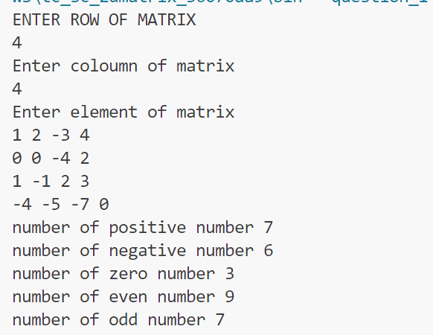

**Q-2: write a program to print the elements above the secondary diagonal in a user inputted**

**square matrix.**

**Code:**

**import java.util.Scanner;**

**public class question_2 {**

**public static void AboveDiagonal(int arr[][]){**

**int m = arr.length;**

**int n= arr[0].length;**

**for(int i=0;i<m;i++)**

**{**

**for(int j=0;j<n;j++)**

**{**

**if(i+j<m-1){**

**System.out.print(" "+arr[i][j]);**

**}**

**}**

**}**

**}**

**public static void main(String[] args) {**

**Scanner sc = new Scanner(System.in);**

**System.out.println("ENTER ROW OF MATRIX ");**

**int m = sc.nextInt();**

**System.out.println("Enter coloumn of matrix");**

**int n = sc.nextInt();**

**System.out.println("Enter element of matrix");**

**int arr[][] = new int[m][n];**

**for(int i=0;i<m;i++){**

**for(int j=0;j<n;j++){**

**arr[i][j] = sc.nextInt();**

**}**

**}**

**AboveDiagonal(arr);**

**}**

**}**

**Output:**

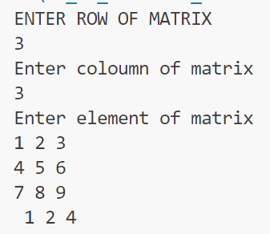

**Q3: write a program to print the elements of both the diagonals in a user inputted square matrix**

**in any order.**

**Code:**

**//time complexity : O(M*N)**

**import java.util.Scanner;**

**public class question_3 {**

**public static void BothDiagonal(int arr[][] ){**

**int m = arr.length-1;**

**int n= arr[0].length-1;**

**for(int i=0;i<=m;i++)**

**{**

**for(int j=0; j<=n;j++)**

**{**

**if (i==j ) {**

**System.out.print(arr[i][j]+ " ");**

**}**

**else if (i+j==m){**

**System.out.print(arr[i][j]+ " ");**

**}**

**}**

**}**

**}**

**public static void main(String[] args) {**

**Scanner sc = new Scanner(System.in);**

**System.out.println("ENTER ROW OF MATRIX ");**

**int m = sc.nextInt();**

**System.out.println("Enter coloumn of matrix");**

**int n = sc.nextInt();**

**System.out.println("Enter element of matrix");**

**int arr[][] = new int[m][n];**

**for(int i=0;i<m;i++){**

**for(int j=0;j<n;j++){**

**arr[i][j] = sc.nextInt();**

**}**

**}**

**BothDiagonal(arr);**

**}**

**}**

**Output:**

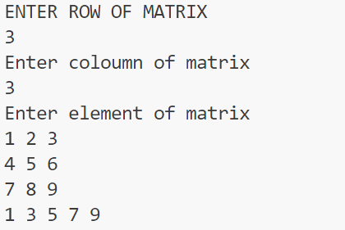

**// time complexity: O(M)**

**CODE:**

**import java.util.Scanner;**

**public class low_time_complexity {**

**public static void BothDiagonal(int arr[][]){**

**int m= arr.length-1;**

**for(int i=0;i<=m;i++)**

**{**

**System.out.print(arr[i][i]+ " ");**

**if (i!=m-i) {**

**System.out.print(arr[i][m-i]+ " ");**

**}**

**}**

**}**

**public static void main(String[] args) {**

**Scanner sc = new Scanner(System.in);**

**System.out.println("ENTER ROW OF MATRIX ");**

**int m = sc.nextInt();**

**System.out.println("Enter coloumn of matrix");**

**int n = sc.nextInt();**

**System.out.println("Enter element of matrix");**

**int arr[][] = new int[m][n];**

**for(int i=0;i<m;i++){**

**for(int j=0;j<n;j++){**

**arr[i][j] = sc.nextInt();**

**}**

**}**

**BothDiagonal(arr);**

**}**

**}**

**OUTPUT:**

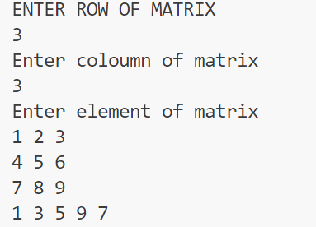

**Q4: Write a program to find the largest element of a given 2D array of integers.**

**CODE:**

**import java.util.Scanner;**

**public class max_element {**

**public static void max_element_print(int arr[][])**

**{**

**int m= arr.length-1;**

**int n= arr[0].length-1;**

**int max = arr[0][0];**

**for(int i=0;i<=m;i++)**

**{**

**for(int j=0;j<=n;j++)**

**{**

**if (arr[i][j]>max) {**

**max = arr[i][j];**

**}**

**}**

**}**

**System.out.println(max);**

**}**

**public static void main(String[] args) {**

**Scanner sc = new Scanner(System.in);**

**System.out.println("ENTER ROW OF MATRIX ");**

**int m = sc.nextInt();**

**System.out.println("Enter coloumn of matrix");**

**int n = sc.nextInt();**

**System.out.println("Enter element of matrix");**

**int arr[][] = new int[m][n];**

**for(int i=0;i<m;i++){**

**for(int j=0;j<n;j++){**

**arr[i][j] = sc.nextInt();**

**}**

**}**

**max_element_print(arr);**

**}**

**}**

**Output:**

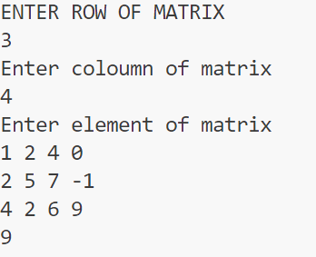

**Q-5: Write a function which accepts a 2D array of integers and its size as arguments and**

**displays the elements of middle row and the elements of middle column. Printing can**

**be done in any order.**

**[Assuming the 2D Array to be a square matrix with odd dimensions i.e. 3x3, 5x5, 7x7 etc...]**

**Code:**

**import java.util.Scanner;**

**public class middle_column_row {**

**public static void middle_column_row_print(int arr[][]){**

**int m = arr.length-1;**

**int n = arr[0].length-1;**

**for(int i=0;i<=m;i++)**

**{**

**System.out.print(arr[i][(arr.length-1)/2] + " ");**

**}**

**for(int i=0;i<=m;i++)**

**{**

**if (i != (arr.length-1)/2) {**

**System.out.print(+arr[(arr.length-1)/2][i]+ " ");**

**}**

**}**

**}**

**public static void main(String[] args) {**

**Scanner sc = new Scanner(System.in);**

**System.out.println("ENTER ROW OF MATRIX ");**

**int m = sc.nextInt();**

**System.out.println("Enter coloumn of matrix");**

**int n = sc.nextInt();**

**System.out.println("Enter element of matrix");**

**int arr[][] = new int[m][n];**

**for(int i=0;i<m;i++){**

**for(int j=0;j<n;j++){**

**arr[i][j] = sc.nextInt();**

**}**

**}**

**middle_column_row_print(arr);**

**}**

**}**

**Output:**

